Rotary Club of the Capital City
34th Annual Capital City Golf Classic

Monday, September 25, 2023
Registration Opens – 8:45 am
Shotgun Start – 10:30 am

North Ridge Country Club
6612 Falls of Neuse Road
Raleigh, NC 27615

Team Information and Handicaps

Team Sponsor Name: _______________________________________________________________________

Team Member Information:

Name Address Phone Handicap*

- ____________________/__________________________________________________/____________________/__________

- ____________________/__________________________________________________/____________________/__________

- ____________________/__________________________________________________/____________________/__________

- ____________________/__________________________________________________/____________________/__________

* NOTE: GHIN handicap index information is required. If a player does not have a handicap, please note their average score for 18 holes.

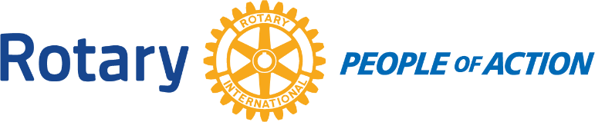
Please email completed forms to Randy Lickey at rlickey.rotary@gmail.com no later than September 14, 2022.

